A000-Mex-Guatemala-Lake Amatitlan-Mayan-Shoe Shaped Ceramic-Anthropomorphic Face-600 CE

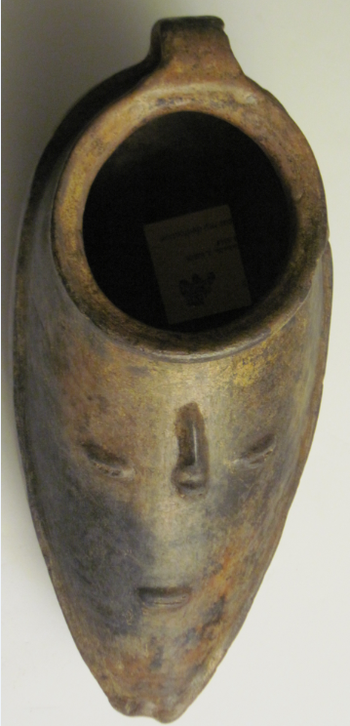  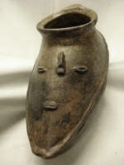

Mex-Guatemala-Lake Amatitlan-Mayan-Shoe Shaped Ceramic-Anthropomorphic Face-600 CE

**Case No.: 10**

**Accession No.**

**Formal Label:** Mex-Guatemala-Lake Amatitlan-Mayan-Shoe Shaped Ceramic-Anthropomorphic Face-600 CE

**Display Description:**

Shoe-shaped vessels such as this were used to dispense chicha or maize beer during ceremonial festivals. Some of these vessels were discarded after use and this one was found by divers in Lake Amatitlan.

**LC Classification:**

**Date or Time Horizon: 600 CE**

**Geographical Area:** Lake Amatitlan

**Map:**

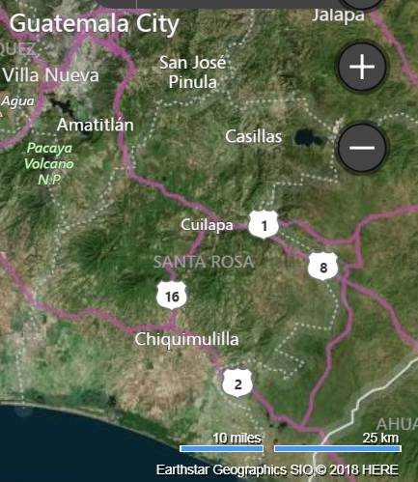 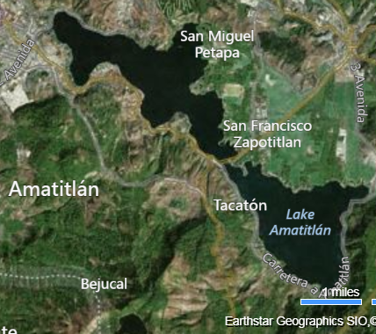

**GPS coordinates**: [14°28′16″N 90°34′54″W](https://tools.wmflabs.org/geohack/geohack.php?pagename=Lake_Amatitl%C3%A1n&params=14_28_16_N_90_34_54_W_region:GT_type:waterbody_source:dewiki)

**Cultural Affiliation: Mayan**

**Medium: ceramic**

**Dimensions:**

**Weight:**

**Condition:**

**Provenance:**

**Discussion:**

**References:**